Table Number:__________ Group Name: ________________________

Group Members:_____________________ _____________________ _____________________

Standard deviation – The Basics

1. Find the Deviations. Given 

|  |  |  |
| --- | --- | --- |
|  | Deviations from | Deviations SQUARED |
| 0 |  |  |
| 5 |  |  |
| 6 |  |  |
| 0 |  |  |
| 2 |  |  |
| 4 |  |  |

|  |  |  |
| --- | --- | --- |
|  | Deviations from | Deviations SQUARED |
| 160 |  |  |
| 125 |  |  |
| 190 |  |  |
| 185 |  |  |
| 105 |  |  |

1. The top speeds (in mph) for a sample of five new automobile brands are listed below. Calculate the standard deviation of the speeds
2. The book cost (in dollars) for one semester's books are given below for a sample of five college students. Calculate the sample standard deviation of the book costs.

|  |  |  |
| --- | --- | --- |
|  | Deviations from | Deviations SQUARED |
| 200 |  |  |
| 130 |  |  |
| 400 |  |  |
| 500 |  |  |
| 345 |  |  |

1. Each of the following distributions have a mean of 60. Without calculating the standard deviation, decide which of the following data sets has the largest standard deviation. Which has the smallest? Explain to your group members WHY you think so. Then check with your graphing calculator.

1. 
2. 10 20 25 95 100 110
3. 50 50 55 65 70 70

**The following list shows the age at appointment of U.S. Supreme Court Chief Justices appointed since 1900. Use the data to answer the question.**

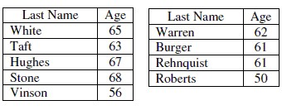

1. The US Supreme Court Chief Justice data was used to create the following output in an Excel spreadsheet. Choose the statement that best summarizes the variability of the dataset.

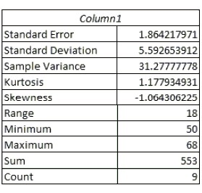

* 1. The ages of most of the US Supreme Court Chief Justices are between 50 and 68 years.
  2. The age of most of the US Supreme Court Chief Justices since 1900 are within 5.6 of the mean age.
  3. The age of most of the US Supreme Court Chief Justices since 1900 are within 31.3 years of the mean age.
  4. None of these.

1. The top nine scores on the organic chemistry midterm are as follows: 74, 39, 80, 57, 43, 69, 21, 34, 69.

Christine is currently taking college astronomy. The instructor often gives quizzes and the following are the top seven scores on the last quiz: 44 20 37 28 19 52 55.

Which set of scores is shows more variation and why?

1. Below is the standard deviation for extreme 10K finish times for a randomly selected group of women and men. Which statement best summarizes the meaning of standard deviation?

Women: *s* = 0.16Men: *s* = 0.25

* 1. The distribution of women’s finish times is less varied than the distribution of men’s finish times.
  2. The distribution of men’s finish times is less varied than the distribution of women’s finish times.
  3. On average, men’s finish times will be 0.25 hours faster than the overall average finish time.
  4. On average, women’s finish times will be 0.16 hours less than men’s finish times.

1. Which of the following measurements is likely to have the **most** variation?
   1. The volume of individual pop cans measured in fluid ounces from a randomly selected twenty-four pack.
   2. The individual weights in ounces of tennis balls in a randomly selected can of tennis balls.
   3. The individual weights in ounces of potatoes in a randomly selected crate of potatoes.